Dillard's Inc. is an American [department store](https://en.wikipedia.org/wiki/Department_store) chain with approximately 292 stores in 29 states and headquartered in [Little Rock, Arkansas](https://en.wikipedia.org/wiki/Little_Rock,_Arkansas). This report focuses on four key areas, firstly Customer’s behavior, preferences and buying patterns. Secondly, the sales performance of Dillard’s stores in Texas over the years and understand which stores are doing well and which warrant more attention. Thirdly, analysis on the performance of top 10 departments which sold the highest items in Texas in 2014 and 2015. Finally, analysis on revenue of various departments and the number of items in stock.

**Analysis of Customer behavior:**

The analysis of how a customer prefers to shop and at what time of the year can give us valuable insights into customer preferences. It is vital to explore customer’s perceptions and purchasing behavior as it is a key driver of store sales. We are trying to assess the behavior of customers who have purchased items at Dillard’s Texas stores, to see if there is a pattern and try to fill in the gaps. It is important to understand customer behavior patterns in order to improve customer shopping experience and increase stores’ revenue.

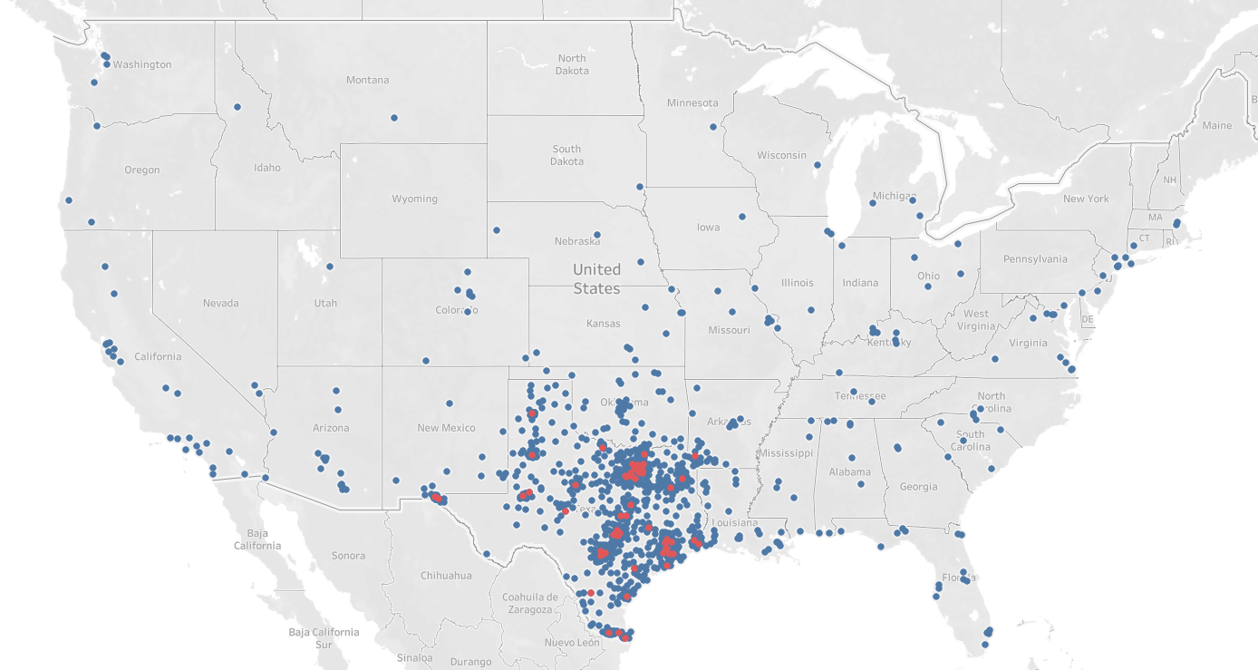

The map above shows us that Dillard’s stores in Texas are fairly popular around the country. We see that the density of people buying from stores at Texas is denser around the areas where the stores are located.

**Busiest season for Dillard’s stores in Texas:**

To deep dive into the data we categorized the months into seasons. February, March and April were grouped as spring. May, June and July were grouped as summer. and August, September and October were grouped as fall. Lastly, November, December and January were grouped as winter.

Using the categories above, we further drilled down into the data by looking for customer buying patterns across seasons. We noticed that more customers shopped from Dillard’s during fall when compared to spring and summer. But as we move towards winter, we see an increase in customers not only in Texas but around the country as well.

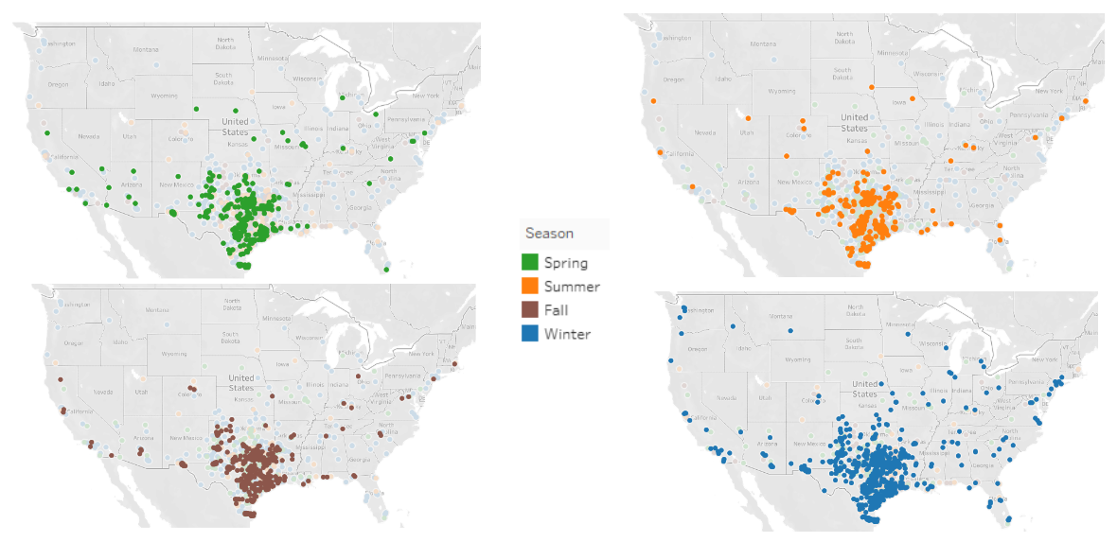

The data set in excel was modified and we subtracted the original price from the transaction amount to get the discount on each transaction (if there were any).

Next, we tried to explore which month had the greatest number of customers and also what might be the reason behind the increased numbers. A bar graph was plotted which had distinct count of customers by month and also by season. We made a similar graph for the discounts by month and also by season. It was observed that there was a direct relationship between discounts that were given by stores to the number of customers shopping at Dillard’s. Comparing the two charts below shows us that a slight increase in discounts offered, causes a good amount of increase in the number of customers buying at Dillard’s.

**Effect of Discount on customer’s behavior:**

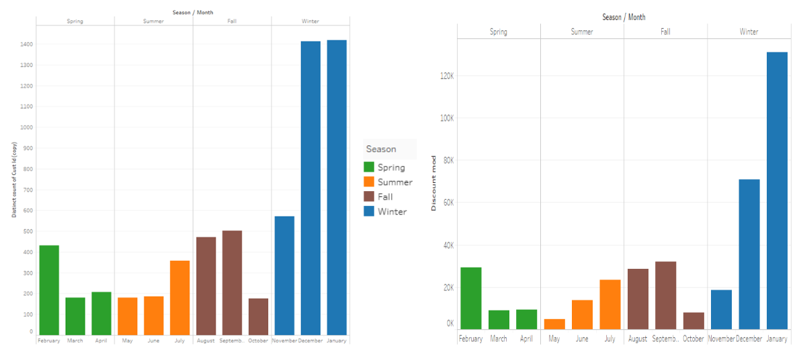

We strongly recommend Dillard’s to introduce “End of Season” sales to bring customers into stores in all seasons thereby reducing pressure of increasing revenue from winter season (November, December and January).

**“Bulk Buyers” or “ Luxury Buyers”**

**Purchase patterns of the top 10 biggest spenders at Dillard’s Store at Texas:**

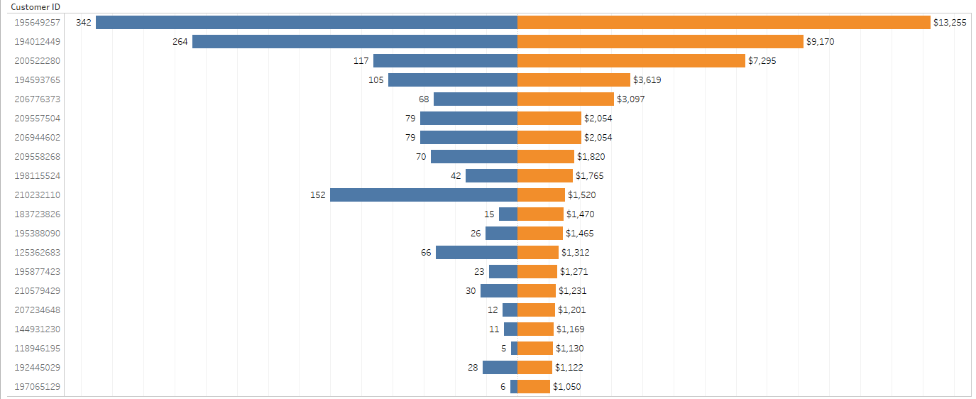 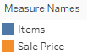

The next step was to identify the customers who spent the most during the year 2014 and 2015. So, we filtered out the top 20 customers who spent the most. We further tried to see the number of items purchased and the amount spent on them. The top spender has spent $13,255 and bought 324 items, so we can say that he/she is a “Bulk Buyer”. We can also see that the 20th top spender has spent $1,050 and has bought 6 items. So, the 20th top spender has bought expensive items and therefore a “Luxury Buyer”. The pattern we see in the top 20 spenders (funnel chart) is that mostly they are bulk buyers.

**Identifying the biggest spenders among loyal customers:**

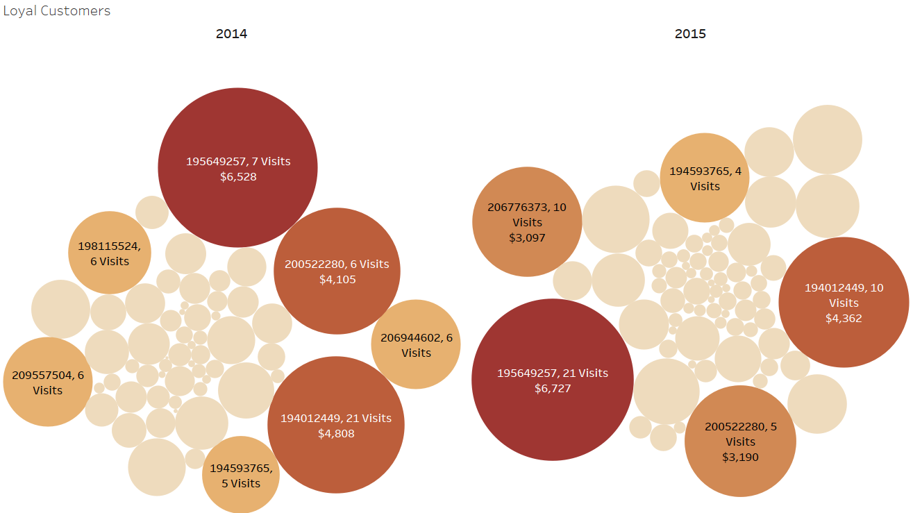 

We also analyzed the customers who had the greatest number of visits and we identified them as “Loyal Customers”. So, we filtered out top 100 customers in our dataset. The size of the bubble shows how much they spent in Dillard’s stores in a particular year. The loyal customer who spent the most in 2014 visited 7 times and spent $6528. The same customer was the highest spender in the year 2015 but his/her visits increased to 21.

We recommend management to tap into the loyal customers pool and encourage them to shop more at Dillard’s by giving a small gift card to top 100 loyal customers with most money spent at the end of the year. This might also encourage other customers to visit and shop at Dillard’s more often in order to win the gift card (or any other prize) next year.

**Sales Analysis on Dillard’s Stores:**

Texas has 61 Dillard’s stores which accounts for almost 20 percent of the total Dillard’s stores across the nation. The main focus is to analyze the sales for these stores and understand which stores are doing well and which stores warrant more attention. Using the sales data for the years 2014 and 2015, we looked at the top and bottom 5 stores in Texas for the given years.

**Top 5 and bottom 5 stores in Texas in terms of sales:**

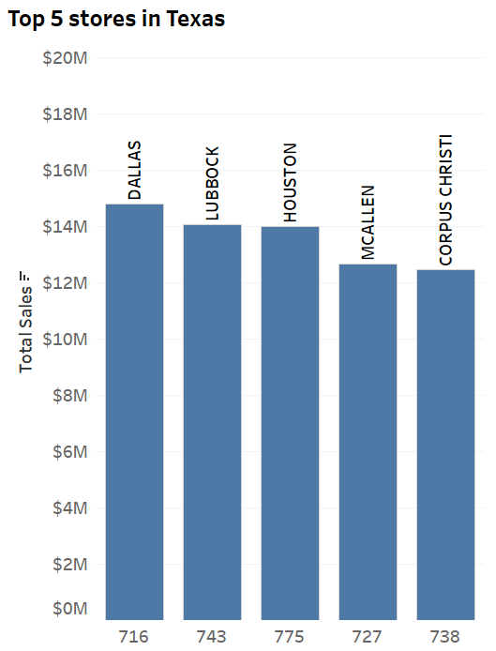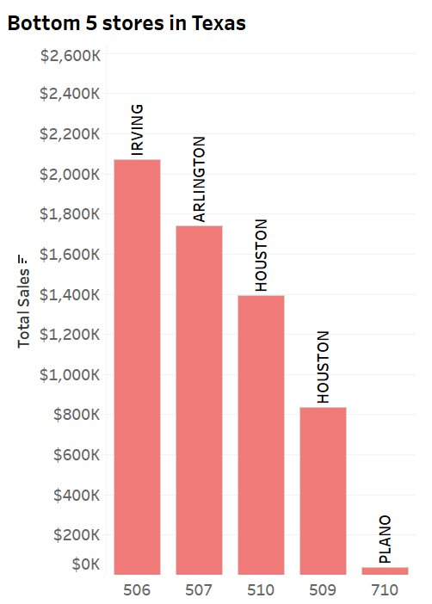

From the above figures, we can observe that sales for the bottom 5 stores is minuscule when compared to the top 5 stores. Also, we found out that two of the stores in bottom 5 are in Houston. Houston is a big city and has 5 Dillard’s stores out of which one is in the top 5 but two are struggling to bring in customers. We looked at the sales of the other stores in Houston to see their performance.

**Performance of stores in Houston**

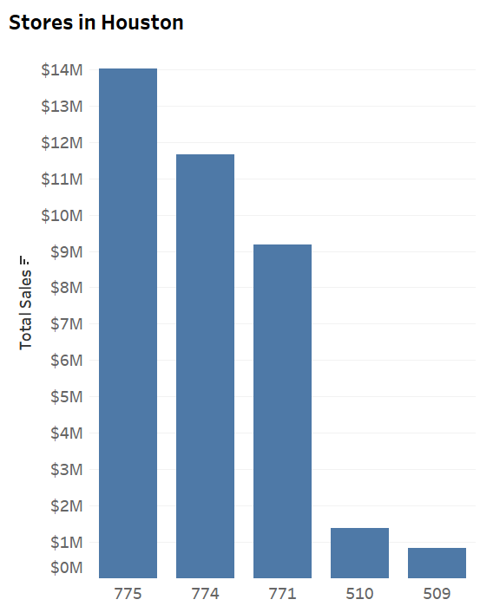

The other three stores in Houston are performing fairly well when compared to 509 and 510. We analyzed the possible reasons for this and found out that the three stores with higher sales have different variety of merchandise to be sold. These stores have a large collection of items and also have different brands which may be one of the reasons why it has higher sales.

**Possible reasons for low sales in 509 and 510:**

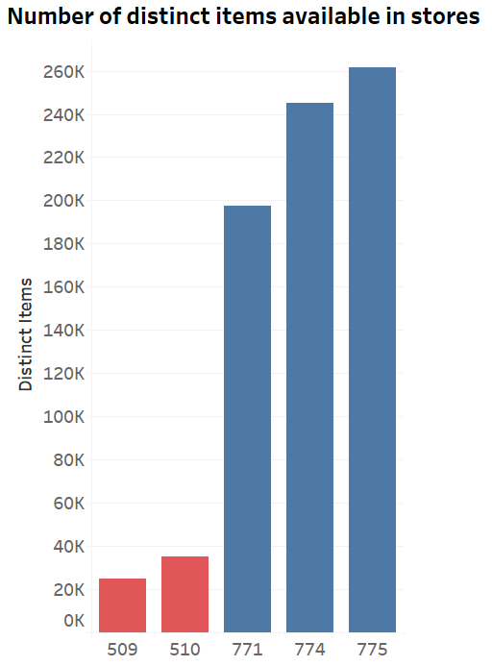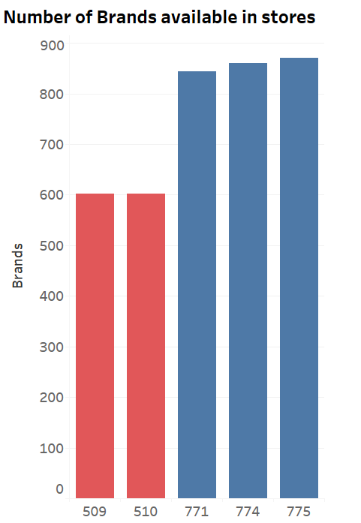

We also looked at how many customers living in the same area as of stores 509 and 510 prefer to shop at these stores. We discovered that only 16.38 % of people prefer to visit the stores 509 and 510. Almost 41 % of people shop at the other three Dillard’s stores in Houston and 43 % of customers prefer to visit stores outside of Houston.

**Preferred stores by customers:**

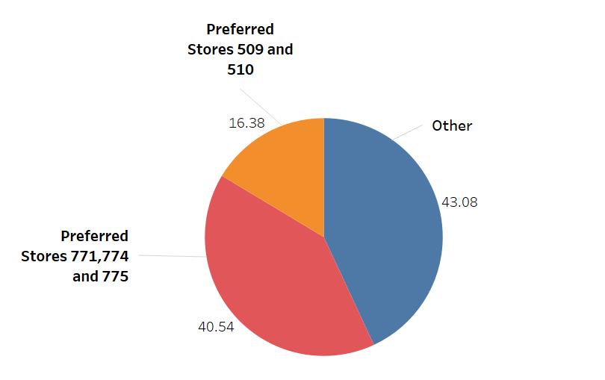

We wanted to analyze whether these stores have the potential to increase sales and attract more customers so we looked at the sales data for these stores and we found that the total sales have increased from the year 2014 to 2015.

**Sales comparison for the stores 509 and 510 over time:**

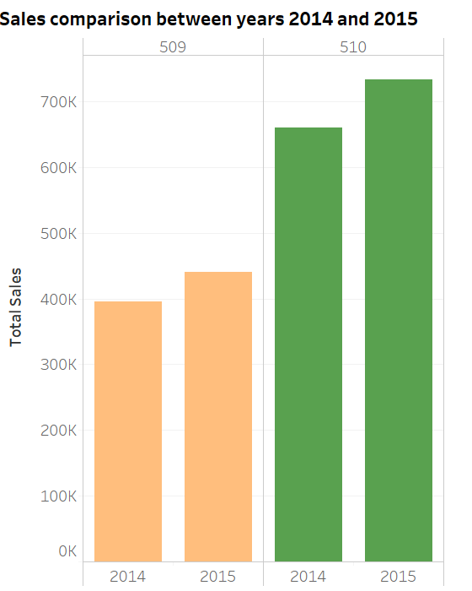

So, we would recommend to introduce new promotional offers at these stores to attract more local customers and also include more variety of merchandise at these stores to increase the total sales.

**Analysis on Dillard’s Departments:**

There are three hundred and sixteen (316) departments operating across all the stores in Texas.

We decided to look at the top 10 departments which sold the highest items in Texas in 2014 and 2015. Our goal was to see if discount had any impact on the number of items sold by these departments.

Comparing items sold and number of customers for 2014 showed that customers actually bought things in bulk across departments. However, in 2015 some departments’ sales dropped while a few (Trend Jewelry & socks/legs) slipped out of ranking from being amongst the top 10 and were replaced by some other departments (Mac & Kors) which did better in 2015. Below visualization gives a clear picture of how these departments fared.

**Top 10 departments with highest number of items sold and No of customers in Texas for 2014 & 2015:**

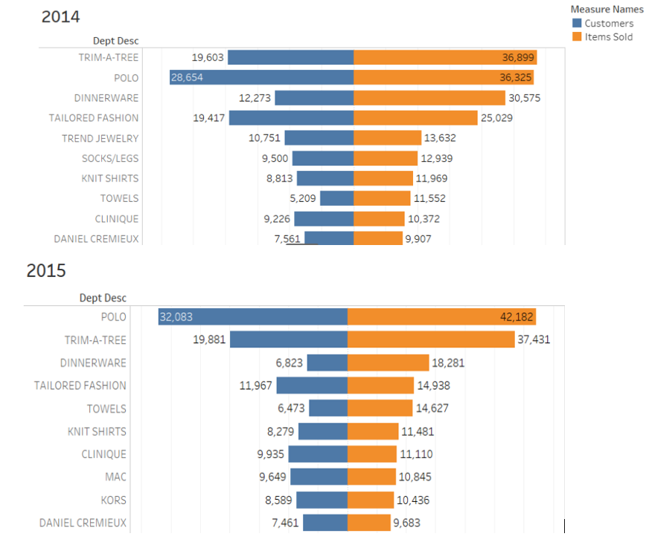

**Percentage increase in discount from 2014 to 2015. Impact of discount on sales in 2015:**

Almost all the departments increased their discounts tremendously in 2015 from what they offered in 2014. This triggered our curiosity, a new dimension to our initial quest was to find out if increase in discount with such a high percentage was normal? The graph below shows departments and discount offered over the years. For clarity, this implies that for a department like Polo; they increased their discount by 56.88% in 2015. We also observed that the company’s sales in 2015 seem not to have picked up as expected despite the huge increase in discounted goods. While there was a spike in sales in Polo and trim-a-tree departments, there was not much difference in sales for other departments. This clearly suggests that while discount impacted sales positively it was not commensurate with the percentage increase. Total items sold in 2014 stood at 199,199 while that for 2015 was 181,014.

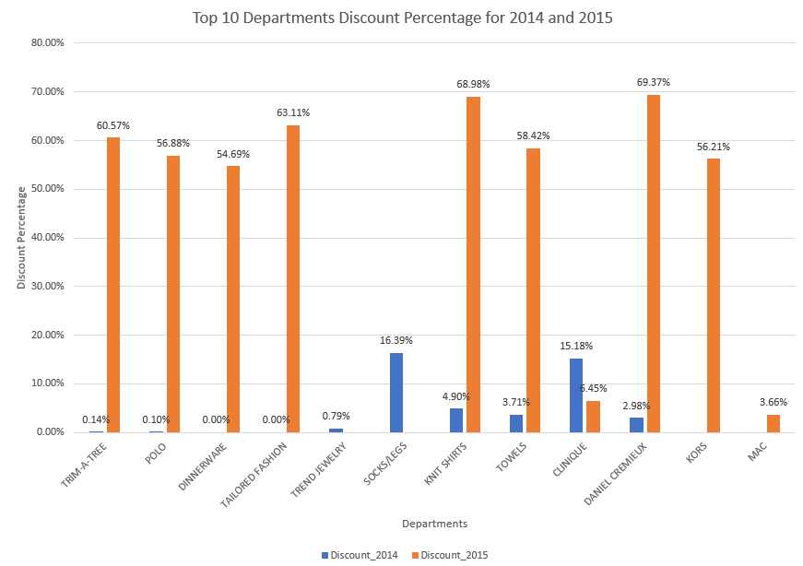

Further investigation showed that 2015 was generally not a good year for Dillard’s, so they needed to increase discount in a manner that they did. While it increased sales in some departments, for others it only helped them even out or push products from their shelves.

Two years may seem short to make a conclusive suggestion on discount considering the economic issues around the world in 2015. We will recommend that Dillard should introduce half year sales discount to help reduce stocks and increase sales such that they will have a few products left as they go into the next financial year. This will ensure that our supply and demand dynamics fits into the economy trend of each year.

**Analysis on Dillard’s SKUs:**

Gross margin equates to net sales minus the cost of goods sold. It shows the amount of profit made before deducting selling, general, and administrative costs and represents the portion of each dollar of revenue that the company retains as gross profit. But, why gross margin? Companies use gross margin to measure how their production costs relate to their revenues. It illustrates how well a company is generating revenue from the costs involved in producing their products and services. Hence, there is a great need to calculate the gross margin every year and assess how well our departments are doing.

**Most and least successful department century in Texas (gross margin):**

Childrens, Juniors, Ready-to-wear are the most successful department centuries in Texas with more than 30% gross margin whereas Cosmetics and Lease are least successful department centuries. Cosmetics incurred huge losses to Dillard’s as their overall gross margin was -2%. To further analyze the department centuries’ performance, we looked at their gross margin over the span of two years.

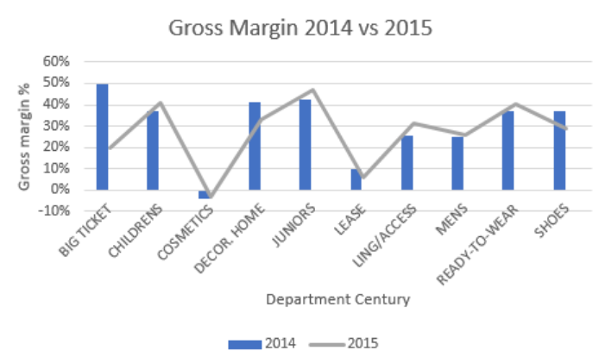

Above visualization shows the performance of the department centuries over the years 2014 and 2015.

Cosmetics and Lease consistently performed poor in 2014 and 2015.

**Least successful brands and their performance over the years (in 2014 and 2015):**

Then we further looked at the brands in these department centuries and analyzed their performance over the years. Below table shows which brands from cosmetics and Lease department century incurred huge loss and their performance over the years:

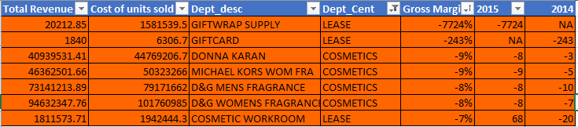

Giftwrap supply brand was introduced in 2015 and has incurred huge loss to the Lease department century and should be given a second thought before restocking this year. GiftCard brand from Lease department century which incurred huge loss in 2014 was discontinued in 2015.

Brands from cosmetics department like Donna Karan, Michael Kors women’s fragrance, D&G Men’s Fragrance and women's fragrance performance was consistently poor in 2014 and 2015. Cosmetic workroom from Lease department century shockingly did well in 2015 and should be restocked in all the stores.

**No of SKUs in stock for least performing brands over years:**

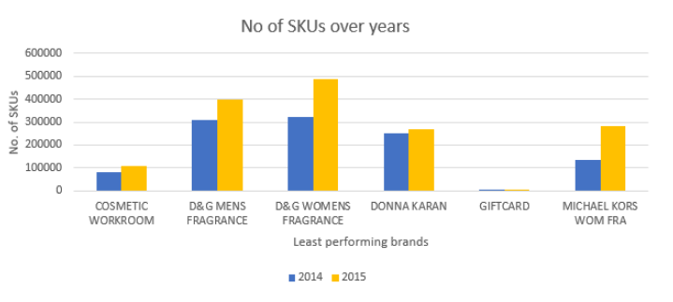

From the above visualization, we can observe that in 2015, the number of items being released increased by huge number despite their poor performance over the years for brands like Donna Karan, Michael Kors women’s fragrance, D&G Men’s fragrance and D&G women's fragrance. Hence, this is a major concern to address and Dillard’s should give a second thought about these brands while restocking them this year.

References:

<https://www.marketwatch.com/story/dillards-profit-sales-fall-below-expectations-2015-11-16>

<https://www.investopedia.com/terms/g/grossmargin.asp>